Pre Show HOOPLA! Lesson Plan 2: Gina’s Notebook

Grade Level: 3-6

Student Learning Objective(s): Students will identify settings in their own neighborhoods which are meaningful in their lives, and become set designers to create illustrations of their settings.

Supplies/Resources Needed: Lined notebook paper, pens/pencils, color pencils, markers, and/or crayons.

California Arts Standards Addressed:
3.VA:Cr1:1 Elaborate on an imaginative idea.
3.VA: Cr2:1 Create personally satisfying artwork using a variety of artistic processes and materials
3.VA: RE:7.1 Speculate about processes an artist uses to create a work of art.
3.TH:Cr1 Imagine and articulate ideas for costumes, props and sets for the environment and characters in a drama/theatre work.

Common Core Standards Addressed:
CCSS.ELA-Literacy.SL.3.4
Report on a topic or text, tell a story, or recount an experience with appropriate facts and relevant, descriptive details, speaking clearly at an understandable pace.

Step by Step Directions for Lesson Plan for Teacher

Activator:
- Ask students if they know what a set designer does for a production. Linked here are some helpful talking points in engaging in a discussion with your class.
- Say: “The set designer for our upcoming Production of HOOPLA! is Jonathan Gilmer. (Meet Jonathan here!) Jonathan developed the ideas for the set for HOOPLA! After reading the script and talking to the director. He then sketched out ideas for his set design, and created a miniature model of his designs, and lastly the La Jolla Playhouse carpenters and technicians built the set!” Go to the POP TOUR website, to the Behind the Scenes DESIGN PROCESS PAGE. At the top of the page, show your students Jonathan’s slide show including his sketches, model, and images of the set. Ask your students to share what they observe in the set design.

Activity:
- Tell the students that today they will become set designers in their own imaginary play about their life based off of the set designs from HOOPLA!
- Say: “Jonathan’s designs are inspired by one of the characters in HOOPLA!, Gina, who loves to immerse herself into her own notebook and sketch and illustrate her life. She doodles, she draws her friends, and she draws her neighborhood.”
- Say: “Let’s generate some ideas for our set designs! But first let’s warm up our brain the way that Gina likes to with some doodles. Draw a rectangle on your paper. In that rectangle, you will have about a minute to doodle whatever you would like to! This is your choice and a way to express yourself. Ready: Doodle!”
  - Time the students for about a minute while they doodle in their notebooks. You can show them the doodles in the slide show if they want some inspiration.
- Say: “Now that we are warmed up, let’s create the set for an imaginary play about our lives. In our set, we will have four different locations each indicated by a drawing in a rectangular section on your paper similar to your doodle. Let’s start one together. The first part of our set design will be of your bedroom. Let’s look at this image of Gina’s bedroom from her sketch in Jonathan’s set design. (Show the students the imaged at the bottom of this lesson plan labeled “Gina’s Bedroom”
  - Ask the students to share what they notice was important to include in this sketch. Note that you cannot see her whole bed and that we are just seeing pieces of who she is.
  - On your paper, make a list of some of props (objects) or set pieces (furniture) you would see in your room. (allow students the time to do this). Once you have your list, you will think about what props or set pieces would be important to include in order to show your room and your personality. For example, Jonathan put a photo of Gina with her Dad because that was important to her. Draw a rectangle on your paper, and now you will illustrate what you would want an audience to see in your room. (Allow students time to illustrate their rooms using colors if they wish).
- Say: “Now we will choose our other three settings for our play about our lives. Your other three places can be any places you want to that will help tell an audience about who you are. Now, make a list of your three places on your paper and what props and set pieces we will see as an audience in those pieces.
  - For students that may need prompting here is a non exhaustive list of other settings for their play: other rooms in their home, parks/playgrounds, school, church, sports fields, theaters, comic book stores, dance studio, restaurant, etc.
  - Say: “Once you have your ideas written down, now you will draw three more rectangles to create your three other places in your set.”
  - Allow students the time to complete their four rectangle set drawings.
- Have students get into small groups and do a design presentation for each other in which they share about their set design and point out details to their peers.
- If you have time, or wish to extend the lesson, students could write monologues or scenes that take place in those locations featuring people they know or fictitious characters.

Closing:
- Bring the students back to the larger group. Have a few students share out something they loved in one of their peers’ design presentations.
- Have students turn to their neighbor and share about what a set designer is, and have one or two students share with the class.
- Ask the students what they are looking forward to seeing or what questions they may have about the set design as it arrives with HOOPLA! In your school soon!

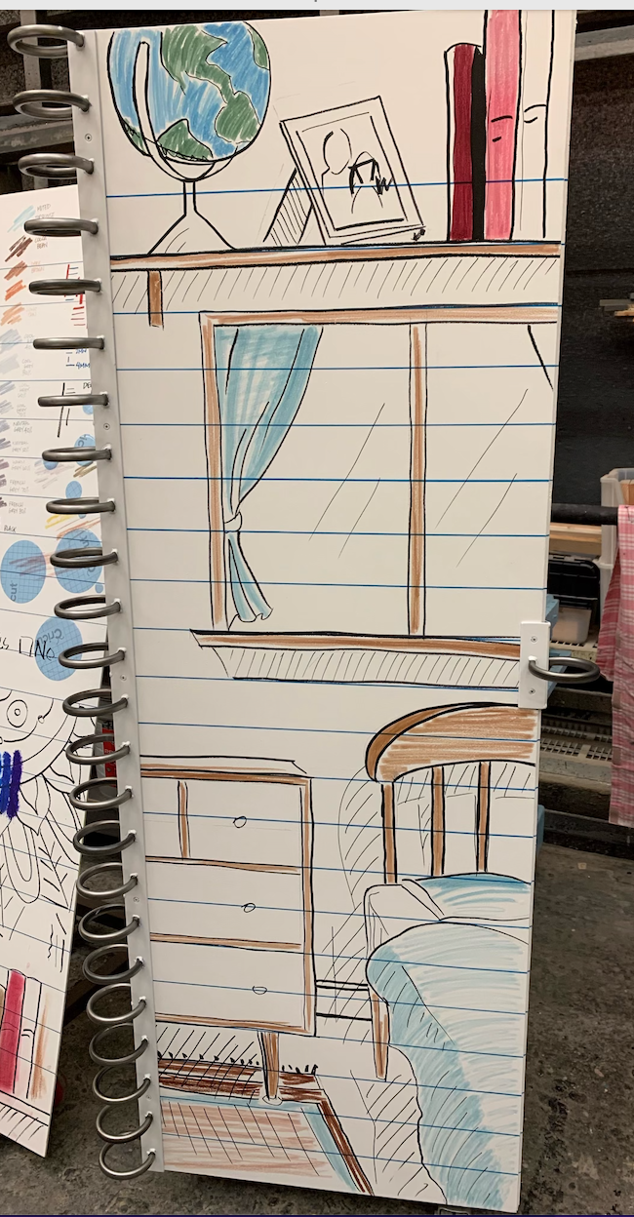
Gina’s Bedroom
Set Design by Jonathan Gilmer

