Post Show HOOPLA! Lesson Plan 2: The Science of LED Hula Hoops.
(This lesson plan was created by students from San Diego State University’s THEA315–Theatre for Young Audiences course and adapted with permission from their professor, Alison Urban)

Grade Level: 3-6

Student Learning Objective(s): Students will conduct an interactive experiment in order to learn more about and create their own LED Light.

Supplies/Resources Needed:
- 5mm or 10 mm LED lights(one per student)
- Watch Batteries(one per student)
- Electrical Tape
- Safety Goggles(one per student)
- Small circular magnets (optional)
- Journal to record observations

Common Core Standards Addressed:
I. Make observations to provide evidence that energy can be transferred from place to place by sound, light, heat, and electric currents.
II. Apply scientific ideas to design, test, and refine a device that converts energy from one form to another.*
III. Ask questions and predict outcomes about the changes in energy that occur when objects collide.

Step by Step Lesson Directions for Teacher:
Pre lesson:
Say to the students:
“The HOOPLA! Trio use LED Hula Hoops in their final talent show performance. What makes these hoops so fun and special, and what is an LED Light? LED is an acronym—does anyone want to take an educated guess as to what LED stands for?” (take a few responses from students)

“LED stands for Light Emitting Diode, which means that it is a semiconductor that gives off light through electricity. A semiconductor is a material that conducts electricity. An LED produces color because of its chemical composition and is showcased because of the electric surge. The variety of color comes from the amount of electricity being used.”

“We can see LED lights in so many places!
Examples are:
-Lightbulbs
-Cars
-Tv's
-Electronics
-and Hula Hoops!”

Lesson/Experiment:
Below are the step by step directions for the science experiment. You can also provide the linked handout here to each student while they are doing the experiment. Students can record their observations in their journal using the scientific method diagrammed below.
1. Pass out safety goggles to each student.
2. Give each student an LED light and a Watch Battery. Have students make an observation or ask a question given the materials they have in front of them. What do they think they will do with those materials? Have students generate a hypothesis.
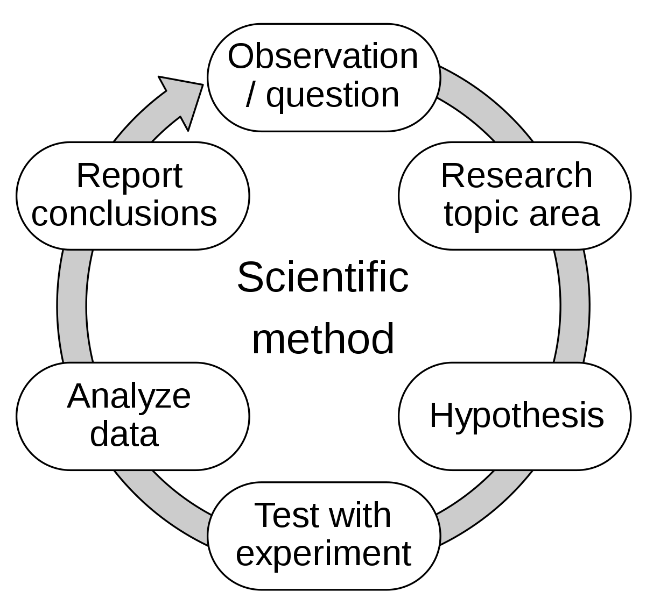
3. Have students carefully put watch battery in between the two wires of the light(the LED should light up at this point, if not flip coin to other side)
4. Support students who may need assistance taping the pieces together.
5. Pass out magnets to each student and put on top of taped coin
6.Place tape around magnet and LED.
7. At this point the LED should be lit and students place it anywhere magnetic around the classroom!
8. Have students document conclusions in their journal and pair share with a neighbor.
Post Lesson:
Class discussion. Choose any of the following questions to reflect as a class on their experiment process.
-What did you learn from this experiment?
-What did you find challenging in the experiment?
-How did you use the scientific method during your experiment? Did you have to make any changes from your original plan?

